

**HUSACCT**

**User manual**

Team 1:

Erik Verhoef 1572690  
René van Aerle 1556647  
Tim Linschoten 1548807  
Niels Nijveldt 1562854  
Stefan Collette 1575795

Teachers: Leo Pruijt, Christian Köppe, Michiel Borkent.

Date: 29-05-2012

Contents

1 System requirements 3

1.1 HUSACCT 3

1.2 HUSACCT Maven plugin 3

2 Workflow 4

3 Menus 5

3.1 File 5

3.1.1 New workspace 5

3.1.2 Open workspace 5

3.1.3 Save workspace 6

3.1.4 Close workspace 6

3.1.5 Exit 6

3.2 Define 7

3.2.1 Define architecture 7

3.2.2 Define architecture diagram 7

3.2.3 Import architecture 7

3.2.4 Export architecture 7

3.3 Analyse 7

3.3.1 Application properties 7

3.3.2 Analyse application 8

3.3.3 Analysed application overview 8

3.3.4 Analysed architecture diagram 8

3.4 Validate 8

3.4.1 Validate now 8

3.4.2 Configuration 9

3.4.3 Violation report 9

3.5 Language 9

3.6 Help 9

3.6.1 About HUSACCT 9

4 Toolbar 10

6 Taskbar 11

7 Maven plugin 12

# System requirements

## HUSACCT

Processor 2Ghz-dualcore processor

Memory 2Gb

Hard disk 20MB available disk space

Display 1024x768 or higher

Operating system Any Java supported OS, preferably Windows7

Additional Software Java JRE 1.6 Update 32 or higher

## HUSACCT Maven plugin

Additional Software Apache Maven 3.0.4 (bin directory added to system path)

Java JDK 1.6 Update 32

# Workflow

When using HUSACCT it is important to know in which order the functionalities can be used. HUSACCT differentiates between several states:

* NONE  
  *No workspace has been created or opened*
* OPENED  
  *A new workspace has been created or opened*
* DEFINED  
  *An logical architecture has been defined*
* APPSET  
  *Application details have been set*
* ANALYSED  
  *An application has been analysed*
* MAPPED  
  *An analysed application has been mapped to the logical architecture*
* VALIDATED  
  *A mapped application has been validated*

The state you’re in defines the function you can use. For example, it is not possible to map an architecture to a physical application if the application has not yet been analysed.

# Menus

## File

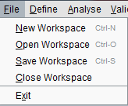

Figure . Filemenu

### New workspace

This opens the New workspace dialog (figure 2). Create a workspace by providing a *Workspace name* and clicking *OK.*

The user is able to analyse an application by checking the Analyse application checkbox and providing the necessary information.

**Note:** It is required to either open a previously saved workspace or create a new workspace to make use of the core functionalities of HUSACCT.

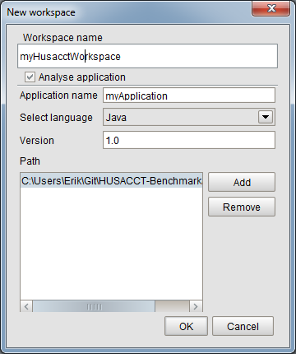

Figure . New workspace dialog

### Open workspace

This opens the Open workspace dialog. The user can choose to open a HUSACCT or XML file.

**Note:** It is required to either open a previously saved workspace or create a new workspace to make use of the core functionalities of HUSACCT.

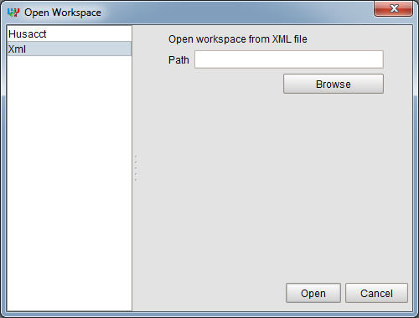

Figure . Open workspace dialog

### Save workspace

This opens the Save workspace dialog. The user is able to save a file to a HUSACCT or XML file.

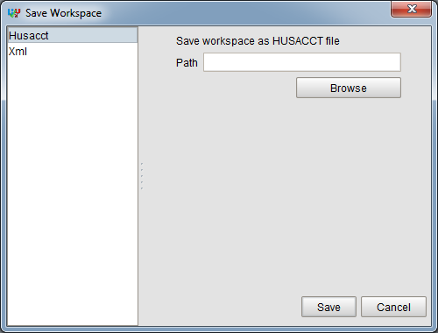

Figure . Save workspace dialog

### Close workspace

This closes the currently opened workspace.

### Exit

This exits the application.

## Define

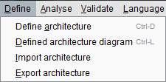

Figure . Definemenu

### Define architecture

This enables the user to define a logical architecture and map an application to it. It is also possible to set architectural rules.

For more details on this component refer to the Define user manual.

### Define architecture diagram

This shows the user a graphical representation of the defined architecture.

For more details on this component refer to the Graphics user manual.

### Import architecture

Import a previously saved architecture into HUSACCT. The architecture file is XML.

### Export architecture

Export a defined architecture to file. HUSACCT only supports XML for exporting the architecture.

## Analyse

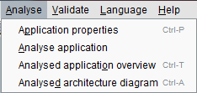

Figure . Analysemenu

### Application properties

This enables the user the set application properties. Users are able to save the properties so they can change any values. Or save & analyse which does exactly that, save the application properties and analyse the application.

For more details on this component refer to the Analyse user manual.

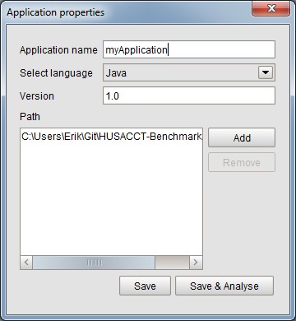

Figure . Application properties dialog

### Analyse application

Analyse the application.

**Note:** The application properties should be set before the application can be analysed.

For more details on this component refer to the Analyse user manual.

### Analysed application overview

Show an overview of the analysed application. It also possible to show the dependencies between classes and packages. These dependencies can also be exported.

For more details on this component refer to the Analyse user manual.

### Analysed architecture diagram

This shows the user a graphical representation of the analysed architecture.

For more details on this component refer to the Graphics user manual.

## Validate

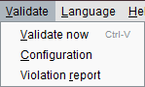

Figure . Validatemenu

### Validate now

This enables the user to validate the application with the given architectural rules.

For more details on this component refer to the Validate user manual.

### Configuration

This enables the user to configure the architectural rules.

For more details on this component refer to the Validate user manual.

### Violation report

This enables the user to export a violation report. The report can be exported to PDF, XML or HTML.

For more details on this component refer to the Validate user manual.

## Language

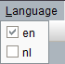

Figure 9.Languagemenu

You can set the application language in this menu.

## Help



Figure . Helpmenu

### About HUSACCT

This shows the details of HUSACCT

# Toolbar

All the buttons in the toolbar are directly linked to the items in the menubar.



Figure 11. Toolbar

The buttons are from left to right:

* New workspace
* Open workspace
* Save workspace
* Define architecture
* Defined architecture diagram
* Application properties
* Analysed application overview
* Analysed application diagram
* Validate

# Taskbar

The taskbar is shown when a frame is opened.

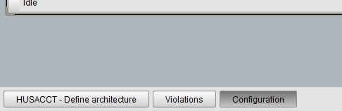

Figure 12. Taskbar

Left-click on a button will put the corresponding frame to the front.

Right-click on a button will open a contextmenu.

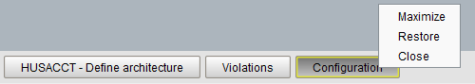

Figure 13. Taskbar with opened contextmenu

Maximize; maximizes the frame.  
Restore; sets the size of the frame to the default and centers the frame.  
Close; close the frame.

# Maven plugin

## Installation

To use the Maven plugin, you will need the original HUSACCT.jar added as a local Maven repository. This is done by executing the following command in command prompt;

mvn install:install-file -Dfile=HUSACCT.jar -DgroupId=husacct.core -DartifactId=husacct-core -Dversion=1.0 -Dpackaging=jar

It is also required to install the plugin to the repository with the following command ran from the root of the plugin directory;

mvn install

This will allow you to run the plugin with Maven.

## Running

The plug-in is run by using the following command in command prompt;

mvn husacct.plugin:husacct-maven-plugin:1.0-SNAPSHOT:husacct

Using this command, it will try to run the “husacct” goal of the “husacct-maven-plugin” version 1.0-SNAPSHOT located within the husacct.plugin repository. The “husacct” goal will try to locate a workspace.hu file within the same directory and generate a report.